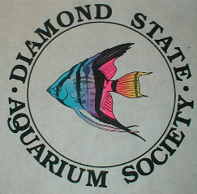
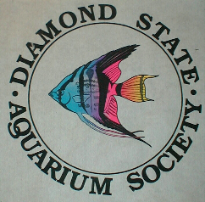
Diamond State
Aquarium Society
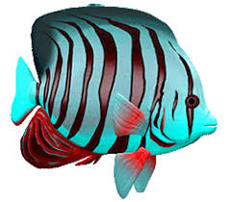

6th Annual Auction

Saturday, October 15th, 2022

Wilmington Manor Lions Club
320 N. DuPont Hwy
New Castle, DE 19720

$1 BIDDER CARDS - CASH ONLY
Refreshments and snacks will be available for purchase
Pre-Register to sell on our website or the day of from 9:00-11:00am
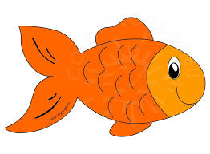
75% to the seller, 25% to DSAS


Auction begins at 12 noon

See our website and/or Facebook for more information
https://dsas.online/

DSAS meets the second Monday night of every month (except June, July, August) at the William Penn High School main cafeteria on Route 141 (Basin Rd) in New Castle, Delaware. Doors open at 6:30pm, meeting starts at 7:00pm. Door prizes, members-only drawings, raffles and auction at every meeting. Open to all ages – free admission.
The Diamond State Aquarium Society is a not-for-profit organization dedicated to the advancement of the tropical fish hobby.

